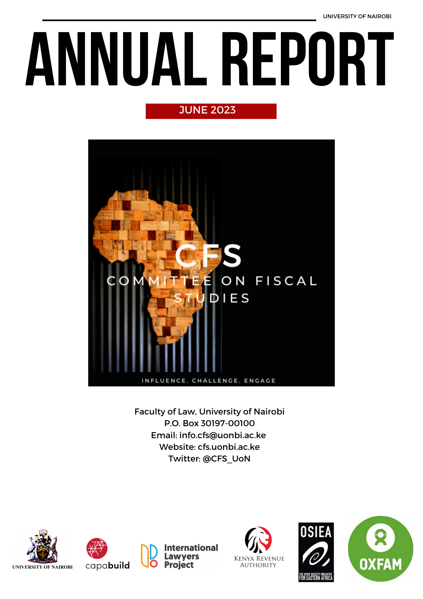

Dear valued stakeholders,

It is with great pleasure that the Committee on Fiscal Studies (CFS) presents our annual report for the year 2022-2023. As a committed group dedicated to reforming and strengthening tax systems in the global south, we continue to push for policies that generate sustainable revenue for developing states and curb illicit financial flows.

Our research projects have made significant contributions towards achieving our goals. Our Tax Talks, Journal on Financing for Development, Policy Briefs Series, Trainings & Capacity Building, Influence & Intervention, and Research support have all been successful in generating knowledge needed for policy advocacy, capacity building, and training. Our policy briefs offer urgent policy solutions that are grounded in historical context and socio-legal analysis, and our journal issues shed light on pressing issues related to fiscal policymaking and debt.

In addition, we launched the CFS Diaries, a platform for sharing reflections on tax themes in simple language to promote a broader understanding of tax issues and encourage more informed public participation in state fiscal policymaking. Our META-X project has also made significant progress, and our African Debt and Human Rights (ADHR) research cluster is work in progress, with numerous research papers and the insights published, podcasts, and interactive dialogues available on our website.

We are proud to have successfully completed six tax trainings with over 200 participants, featuring guest lecturers from Capabuild, PwC, WATAF, UNDP, Parliament, International Lawyers Project, and TJNA. Our tax talks have also been successful in bringing together leading experts in the tax field, offering a diversity of perspectives and approaches. Furthermore, we are excited to have supported Capabuild in developing the Tax Aggregator Portal (TAP), a learning platform that brings together available resources online to assist researchers, learners, practitioners, and professionals in their professional development. We shall be launching TAP soon.

Our projects have been supported by grants from OSIEA, Oxfam International, and GIZ, and we are expanding our network of partnerships. We are proud to have signed Memorandums of Understanding (MoUs) with several organisations, including Capabuild Foundation, Kenya Revenue Authority, and International Lawyers Project. Our partnerships with prestigious institutions such as the South Centre, WATAF, and Facultad de Derecho de la Universidad de Buenos Aires have also been instrumental in advancing fiscal studies in the region and beyond.

We remain committed to our mission to reform and strengthen tax systems in the global south and are optimistic about the future following various appointments of our members to international and regional organisations, with some taking visiting fellowships in the UK and the Netherlands. We would like to express our gratitude to our stakeholders, supporters, funders, and member for their contributions to the success of our projects. We look forward to continued growth and development and encourage you to join us on this journey.

Sincerely,
Dr. Lyla Latif (PhD)
Chairperson, Committee on Fiscal Studies (CFS)
Table of Contents

1. Journal on Financing for Development 4
2. Policy Brief Series 4
3. CFS Diaries 6
5. Learn with Us 6
6. META-X Project 7
7. ADHR Project 7
8. Tax Training 8
9. Tax Talks 8
10. Tax Aggregator Portal 9
11. Funding 9
12. Memoranda of Understanding 10
13. Other Activities 10
14. Our Researchers 11

Journal on Financing for Development

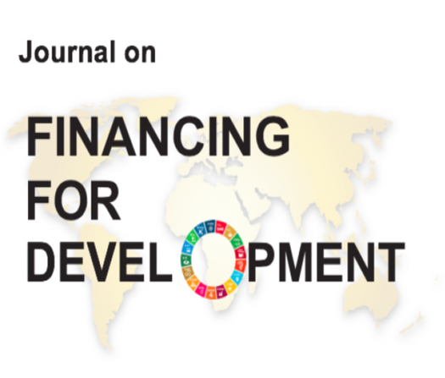
We published our 2022 special issue of the Journal on Financing for Development, which is dedicated to the work of the UN Independent Expert on Foreign Debt and Human Rights - our very own Prof. Attiya Waris. This issue sheds light on the pressing need for transparency, clarity, and participation in fiscal policymaking related to debt, and examines its impact on financing progress towards the achievement of human rights. You can access and read the special issue here:
http://uonjournals.uonbi.ac.ke/ojs/index.php/ffd/issue/view/142

The 2023 issue of our annual journal is dedicated to the scholarship of Prof. Sol Picciotto, an internationally recognized tax expert and academic. Picciotto's contributions to tax scholarship have been invaluable, and his work has influenced tax policies globally. Our journal issue pays tribute to his legacy by featuring articles and research papers that build on his work and explore new frontiers in tax scholarship. We are proud to honour Picciotto's contributions to tax scholarship and hope this issue inspires new ideas and innovations in the field.

Policy Brief Series
Our policy briefs are the cornerstone of our research agenda. They tackle urgent policy problems and offer potential solutions, grounded in historical context and socio-legal analysis to support our recommendations. We recently published several policy briefs that address critical tax issues, including contributions from renowned experts such as Prof. Annet Oguttu, John Bush, Michael Durst, Dr. Okanga Ogbu, Abdul Muheet Chowdhary, and Dr. Radha Upadhyaya. To access our policy briefs, visit:
http://erepository.uonbi.ac.ke/handle/11295/106975
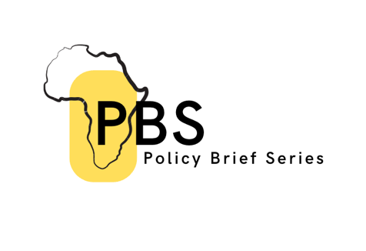

Below is an overview of our published policy briefs:

- Reducing African Countries Debt Reliance. This brief proposes four key strategies: developing local currency bond markets, attracting foreign direct investment, accessing grants from international organisations and foundations, and utilising crowdfunding platforms. By implementing these recommendations, African countries can build more sustainable and resilient economies, promote economic growth, and ultimately improve the well-being of their citizens.
- Digital Credit Over-Indebtedness, Debt Literacy and Attitudes: Financial experiences of youth digital credit users in Kenya. This brief explores the financial experiences of young people who use digital credit in Kenya. It examines the issue of over-indebtedness, debt literacy, and attitudes towards borrowing and repayment.
- The Taxation of the Digital Economy: The OECD BEPS Policy Response Versus the UN FACTI Panel’s Principle Response. This brief compares the responses of the OECD BEPS policy and the UN FACTI panel to the challenges of taxing the digital economy. It explores the policy and legal implications of these responses for developing countries.
- Negotiating Bilateral Tax Treaties: Should Tax Treaties Involving Low-income Countries Contain a Sunset Clause? This brief examines the issue of sunset clauses in bilateral tax treaties involving low-income countries. It explores the advantages and disadvantages of including sunset clauses in these treaties.
- Taxation of Computer Software: Need for Clear Guidance in the UN Model Tax Convention. This brief addresses the issue of taxing computer software and the need for clear guidance in the UN Model Tax Convention. It explores the legal and policy implications of taxing software and provides recommendations for policymakers.
- Impact of the OECD Inclusive Framework’s Pillar 2 on Developing Countries: A Focus on Tax Incentives. This brief examines the impact of the OECD Inclusive Framework’s Pillar 2 on developing countries, with a focus on tax incentives. It explores the implications of the Pillar 2 proposals for tax policy in developing countries.
- Curtailing Base Erosion and Profit Shifting: The Progress and Challenges of Implementing Provisions to Enable International Exchange of Information in Tax Matters in Africa. This brief examines the progress and challenges of implementing provisions to enable international exchange of information in tax matters in Africa. It explores the legal and policy implications of these provisions for curtailing base erosion and profit shifting.
- Taxation on the Digital Economy. This brief provides an overview of the state of taxation on the digital economy. It explores the policy and legal challenges of taxing the digital economy and provides recommendations for policymakers.
- Source v Residence Taxation. This brief examines the issue of source versus residence-based taxation. It explores the advantages and disadvantages of these tax systems and provides recommendations for policymakers.
- Understanding The Global Data On Illicit Financial Flows: A Legal Perspective. This brief provides a legal perspective on understanding the global data on illicit financial flows. It explores the legal and policy implications of illicit financial flows and provides recommendations for addressing this issue.
- Financing Government’s ‘Cinderella’: Establishing the need to mobilise additional sources of revenue to fund the Kenyan healthcare sector. This brief examines the need to mobilise additional sources of revenue to fund the Kenyan healthcare sector. It explores the legal and policy implications of financing the healthcare sector and provides recommendations for policymakers.

CFS Diaries
We've launched the CFS Diaries, a platform for sharing reflections on tax themes without the technical jargon. Our aim is to promote a broader understanding of tax issues and encourage more informed public participation in state fiscal policy making. Check out our diaries here:
https://cfs.uonbi.ac.ke/cfs%20diary



Some content published in CFS Diaries include:

- "The Challenges of Imposing a Wealth Tax in Africa" explores the potential benefits and challenges of implementing a wealth tax in African countries to address wealth inequality. It highlights the limited data on the wealth of individuals and corporations, tax evasion, brain drain, disincentive for investment, administration costs, and legal challenges as the primary challenges to imposing a wealth tax.
- "Achieving Economic Development in Africa Through Progressive Taxation" discusses the potential of a progressive tax system to promote income equality, fund social programs, and reduce reliance on external borrowing and debt in African countries. It also mentions the challenges of implementing a progressive tax system, such as the need for strong political will and effective tax administration.
- "Taxation as a Human Right: Financing Equitable and Accessible Healthcare" highlights the importance of taxation in financing healthcare services and ensuring that everyone has access to quality healthcare, regardless of their income or social status. It promotes the concept of Taxation as a Human Right, which promotes distributive justice and fair burden-sharing of financing healthcare.
- "The Challenge of Taxation and Jurisdiction in the African Metaverse" explores the challenges around taxation and jurisdiction in the emerging digital world of the metaverse, which is rapidly attracting attention from African countries. It discusses the need to create new tax laws that apply to virtual goods and services and establish global laws and international court systems to protect African citizens in the metaverse.

Learn with Us

We have a page dedicated to supporting research work. We have published the content below to help build research skills.

Basics of Research - Getting Started
Navigating Tax Scholarship and Research - Being Mindful of your Positionality
Thinking of Fieldwork? Know the Basics
How to Code Data - A Brief Guide
Decolonising Research? How do we go about this?
Literature Review - Where Do I Start?
Applying Theory - Key Reflections

META-X Project

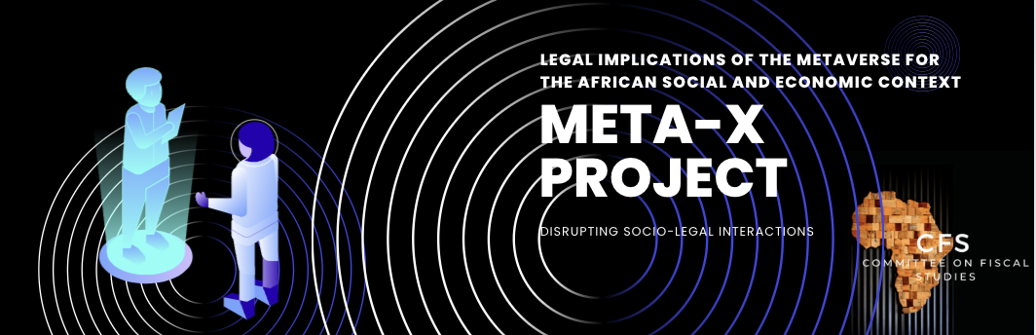
The metaverse has the potential of creating global disorder, if not regulated and understood. The metaverse has established new marketplaces with globally registered accounts nearing 800 million and revenues approaching USD 1 billion annually. These marketplaces are accessible to countless companies, fraudsters, and other criminals. Metaverse offers governments with the potential to mobilise more revenue, which can be used to improve livelihoods. But do we have an idea of the forms of illicit financial flows (IFFs) the metaverse can foster? What about its potential to create new law? Or influence the pathways and streams for international finance and revenue mobilisation for states? We've published a briefing paper on our preliminary findings. To learn more about our META-X project, check out our website: https://cfs.uonbi.ac.ke/meta-x

ADHR Project

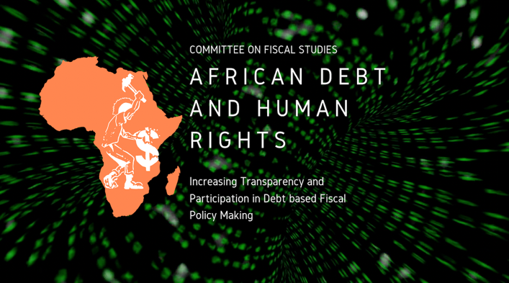
Our African Debt and Human Rights (ADHR) research cluster is work in progress, with numerous research papers and the fiscal eye published, podcasts, and interactive dialogues available on our website. Our ADHR project aims to support research, clarity and participation in fiscal policy making relating to debt and human rights in Africa. ADHR seeks to develop an African inspired financial model of development, free from entanglements with illicit financial flows, where debt is utilised sustainably, sought as last resort and secured through financial systems and creditors based on the borrowing state’s terms. To learn more about our ADHR project, visit: https://cfs.uonbi.ac.ke/ADHR

Some of the papers published under this project, include:

- Resolving the Debt Sustainability Issues from a Legal and Institutional Perspective-A Kenyan Case study
- Resolving the Debt Sustainability issues From a Legal and Institutional Perspective A Focus on East Africa
- Is Africa’s Fiscal Space Undermined by Debt related Illicit Financial Flows? Study of Selected SADC Member States.
- The Tension Around the Right to Information versus Non-Disclosure Clauses in Loan Contracts
- The Impact of Foreign Debt on the Right to Health
- Public Participation in Fiscal Decisions on Foreign Debt
- Special Drawing Rights and Its Impact on Economic Justice.
- Achieving Social and Economic Sustainability Using Islamic Social Finance: A Kenyan Case Study

Tax Training
We've successfully completed 8 tax trainings with over 200 participants, featuring guest lecturers from Capabuild, PwC, WATAF, UNDP, Parliament, International Lawyers Project, and TJNA. Our trainings are focused on improving knowledge and understanding of tax technicalities. The Tax Appeals Tribunal (Kenya) and the Botswana Unified Revenue Service are some of the beneficiaries of our bespoke training. To learn more about our tax trainings and access our course material, visit: https://cfs.uonbi.ac.ke/Courses



Click on the links to the courses taught to access some of our material:

- Financing Development
- Digital Economy and its Taxation
- Professional Enablers: Illicit Financial Flows and the Role of Lawyers
- Taxation and Gender
- Transfer Pricing
- Taxation of the Extractives Sector
- Researching Finance for Development
- Taxpayers Rights

Tax Talks
With over 50 tax talks under our belt, we’ve gathered a wealth of insights from leading experts in the tax field. Our presenters come from a wide range of backgrounds, including UN bodies, international organizations, academia, and civil society, ensuring a diversity of perspectives and approaches. Whether you're interested in tax reform, redistribution, or social and development policy, our tax talks have something for everyone. So why wait? Check out our recorded talks today and start learning here: https://www.youtube.com/channel/UCLGe1XT6bl-EZlK5rQBEAZw/videos

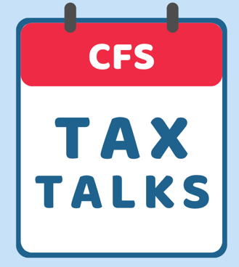

Tax Aggregator Portal

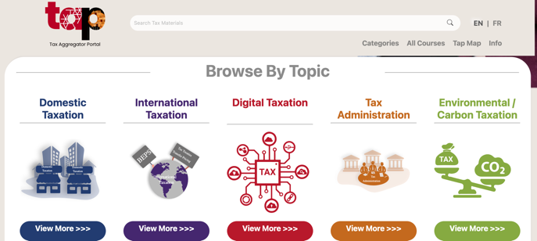

This year (2023) we will launch the Tax Aggregator Portal. Led by Capabuild and supported by our researchers, we have combined our skills and knowledge to bring this portal to the service of researchers, learners, practitioners and professionals everywhere. This learning portal serves to aggregate, and bring together, available resources online so that each user can choose which may suit their needs in their own professional development. It has been arranged in a way that helps users select the most relevant categories to them, as well as consider the hurdles that must be overcome to complete the learning. Keep an eye out for the launch happening very soon!

Funding
We benefitted from the following grants:

An award of USD 265,000 funding from OSIEA to support our activities (Dr. Attiya Waris as Principal Investigator)

An award of USD 100,000 for 2 years funding from OSIEA to support training on debt and human rights to increase participation in fiscal policy and research. (Dr. Lyla Latif and Bosire Nyamori as Co Principal Investigators)

An award of EUR 9,500 from Oxfam International, PAP Kenya to research on taxing the digital economy and proposing fiscal reforms. (Dr. Lyla Latif as Principal Investigator)

An award of USD 11,000 from Oxfam International, PAP Kenya to conduct a cost and benefit analysis of tax incentives in selected African countries. (Dr. Lyla Latif as Principal Investigator)

An award of EUR 49,000 from GIZ to conduct research on collective investment vehicles. (Dr. Attiya Waris as Principal Investigator)


GRANT AWARDS

Memoranda of Understanding
We are expanding our network of partnerships. We are proud to have recently signed Memoranda of Understanding (MoUs) with several organisations, including Capabuild Foundation, Kenya Revenue Authority, and International Lawyers Project.

We are pleased to maintain strong working relationships with other prestigious institutions, such as the South Centre, West African Tax Administration Forum (WATAF), UN Independent Expert on Foreign Debt and Human Rights, and Facultad de Derecho de la Universidad de Buenos Aires. These partnerships enable us to collaborate on important research and policy issues, share knowledge and expertise, and contribute to the advancement of fiscal studies in the region and beyond.




Other Activities

We have submitted commentaries to government and hosted podcasts. Our members have also been gaining global traction.

COMMENTARIES | PODCASTS | LUMINARY ACHIEVEMENTS
Further Proposals on the Amendment of the Public Debt Limit, Submitted to the National Treasury and Economic Planning  Kenya National Tax Policy Proposals, submitted to the Ministry of Finance (Kenya)  Response to AFRODAD’s Public Debt Toolkit  Observations on a Global Beneficial Ownership Register submitted to the UNIE  Situation of Human Rights in Kenya Amid Multiple Crises submitted to the UNIE | Conversation with Winnie Kemunto Mageto (Economist) on 'Resolving the Debt Sustainability Issues in East Africa from a Legal and Political Perspective'.  Conversation with Omar Saleh on 'Intervention using Islamic Social Finance to Relieve Foreign Debt Pressures'.  Conversation with Winnie Nkatha (Economist) on 'Resolving the Debt Sustainability issues from a legal and political perspective in Kenya'.  Conversation with Lyla Latif on Wealth Tax and Feminism Part 1  Conversation with Lyla Latif on Wealth Tax and Feminism Part 2 | Dr. Attiya Waris appointed as the UN Independent Expert on Foreign Debt and Human Rights  Dr. Attiya Waris appointed as member of the O’Neill Lancet Commission on Racism, Structural Discrimination and Global Health  Dr. Radha Upadhyaya on a visiting research fellowship at the London School of Economics  Bosire Nyamori on a research visit to IBFD  Dr. Lyla Latif appointed to the boards of Tax Justice Network, International Lawyers Project and the Tax Law Committee of the East Africa Law Society. She is also leading UNDP country missions on Tax for SDGs  Dr. Nicholas Orago appointed Dean, Faculty of Law, Maseno University  Dr. Parita Shah at the first Mutual Learning on R&I policies and strategies in Ethiopia in partnership with the UN Inter-agency Task Team

Our Researchers
The number of CFS researchers has increased significantly, and we have invested in training them on research methodologies, and academic writing. The researchers have been exposed to working with our partners, which has enabled them to broaden their knowledge and expertise. We have also hosted several webinars, where researchers have shared their findings and engaged with other professionals in the field.
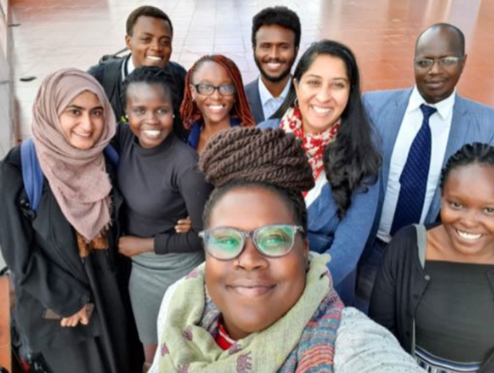

Our current researchers are:

Learnmore Nyamudzanga | Waridah Makena | Polycarp Okumu | Merlene Amonde | Vallarie  Yiega
Brenda Nasambu Wangila | Omar Mohammed | Sharon Nyaboke | Moses Muchiri | Annette Nabayi
Trevor Kanogu | Clara Kitungulu | Mwaniki Maina | Colins Mugo | Prisca Musibi
Susan Yara | Kamara Foday | Guinevere Debrah Kahyah | Joshua Kengere Mogaka | Omeri  John

You can learn more about our work by visiting our website.



Interested in contributing to our journal, writing a policy brief, or sharing your insights on tax-related issues? Interested in joining our mentorship program?
Get in touch: info.cfs@uonbi.ac.ke or
Tweet at us: @CFS_UoN

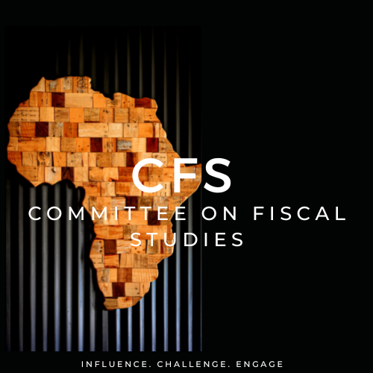

Governance Policy | Data Protection Policy

